


Sri Sri University
Predictive Maintenance for Aircraft Engines & Aviation Safety

LOW-LEVEL DESIGN
Predictive Maintenance

Baccalaureus Technologiae
Faculty Of Engineering & Technology

SUBMITTED BY
Subham Nayak | FET-BDS-2022-26-019
Indigibilli Harshit | FET-BDS-2022-26-015
Dhruti Deepam Mohapatra | FET-BDS-2022-26-005
Khushi Singhania | FET-BDS-2022-26-013
Lokesh Patra | FET-BDS-2022-26-20

Under the Guidance of
Dr. Pradipta Kumar Mishra
Asst. Professor
Faculty Of Engineering & Technology
Sri University

1.Introduction

1.1 Scope of the document:

This document outlines the low-level design (LLD) of a predictive maintenance system for aircraft engines. It covers the design aspects of machine learning models such as Linear Regression, Long Short-Term Memory (LSTM), Recurrent Neural Networks (RNN), Gradient Boosting (GBU), and Random Forest (RF). Additionally, it includes data preprocessing, model training, evaluation, and visualization techniques required for developing a proactive maintenance solution.

1.2. Intended Audience:

The intended audience for this document includes data scientists, machine learning engineers, aviation maintenance experts, and project stakeholders involved in the development and implementation of the predictive maintenance system.

1.3. System Overview:

The predictive maintenance system aims to leverage machine learning techniques to analyse sensor data, flight patterns, and historical maintenance records to predict the likelihood of engine failure in aircraft. By identifying potential issues before they occur, the system enables proactive maintenance scheduling, reducing unplanned downtime and enhancing aviation safety.

2. Low-Level System Design

2.1. Model Architecture:

This section describes the architectural design of the machine learning models employed in the predictive maintenance system, including Linear Regression, LSTM, RNN, GBU, and RF. Architectural diagrams highlighting the layers, connections, and flow of information will be provided. The architecture should clearly illustrate how data flows through each model and how predictions are made.

2.2. Model Training:

Here, we detail the training process for each machine learning model, including optimization algorithms, hyperparameter tuning, and cross-validation techniques. Code snippets for training each model will be provided, along with explanations of key parameters and techniques used.

2.3. Model Evaluation:

This section presents the evaluation metrics and methodologies used to assess the performance of each predictive maintenance model, including accuracy, precision, recall, and F1 score. Visualizations comparing model performance will be included.

3. Data Design

3.1. Data Loading and Concatenation:

This section covers the loading and concatenation of datasets containing information about aircraft engine performance. Data preprocessing steps, such as feature engineering and labelling, will be described.

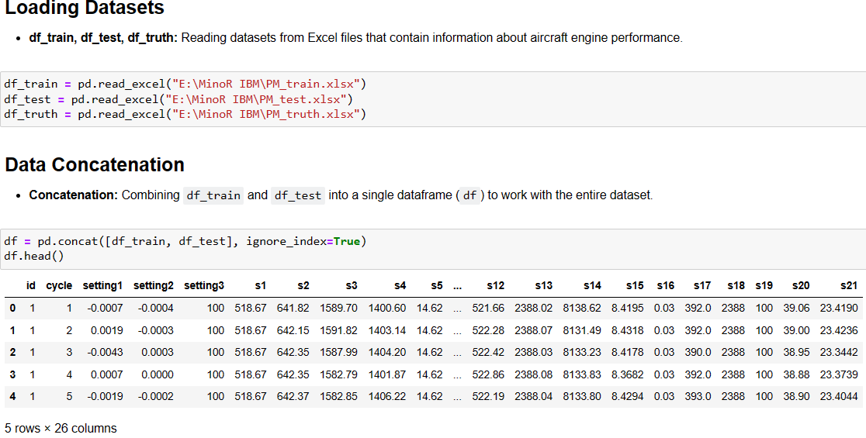

3.2. Feature Engineering

Feature engineering techniques, such as calculating Remaining Useful Life (RUL), will be detailed. Feature columns for model training will be defined.

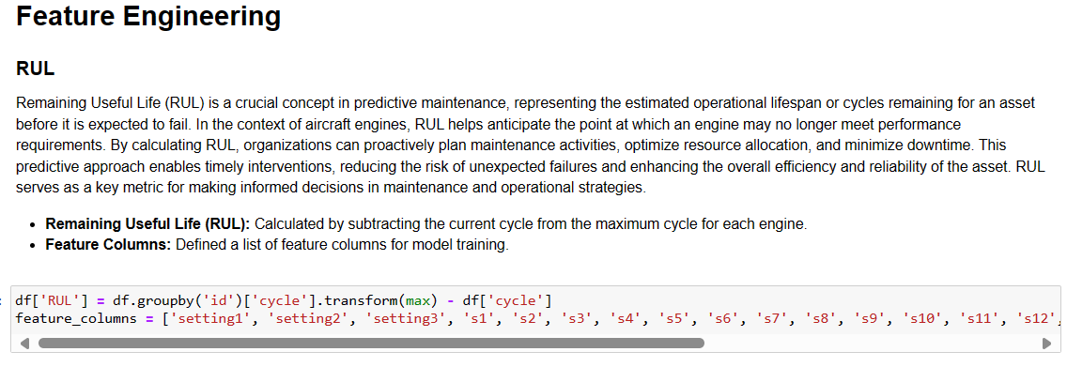

4. Model Implementation and Evaluation

4.1. Linear Regression Model

Code for implementing and training the Linear Regression model will be provided, along with model evaluation metrics such as accuracy and mean squared error (MSE).

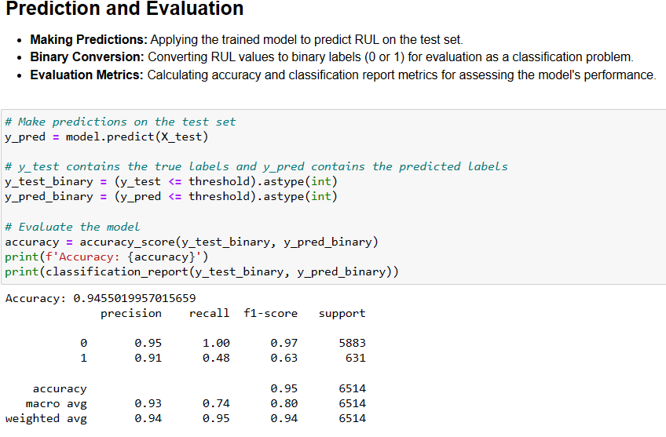

4.2. LSTM Model

Code for implementing and training the LSTM model will be provided, along with model evaluation metrics.

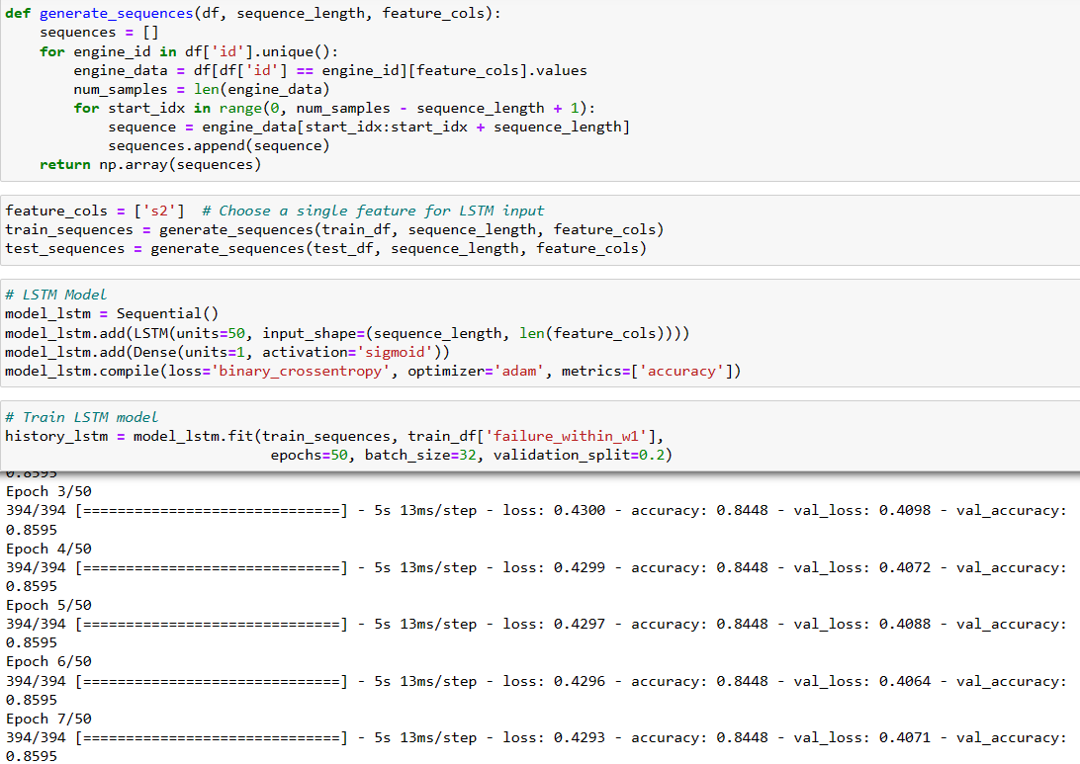

4.3. RNN Model:

Code for implementing and training the RNN model will be provided, along with model evaluation metrics.

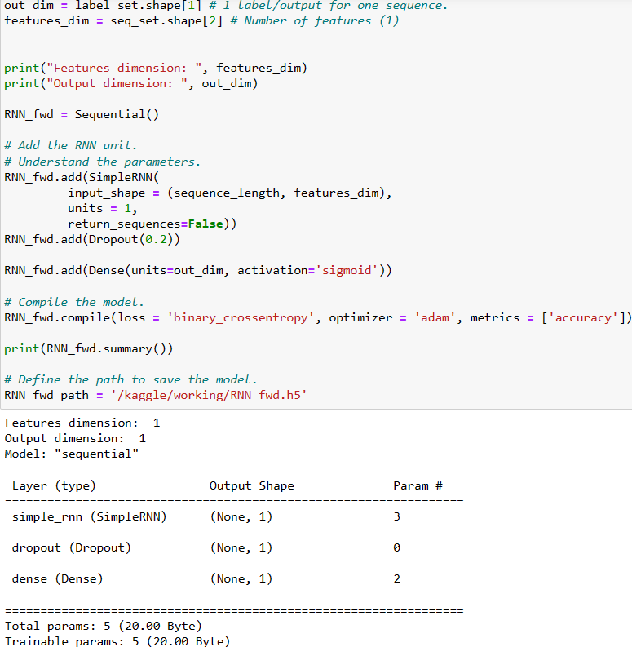

4.5. Random Forest Model (RF):

Code for implementing and training the RF model will be provided, along with model evaluation metrics.
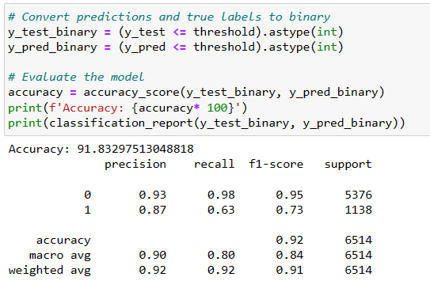

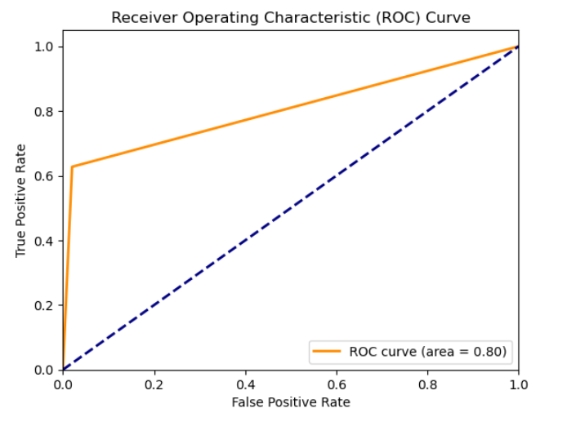

5. Visualization and Comparison

5.1. Model Performance Visualization:

Visualizations comparing the performance of different predictive maintenance models will be provided, including accuracy, precision, recall, and F1 score.

LSTM Model

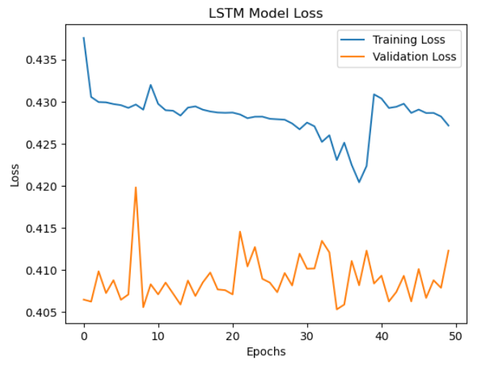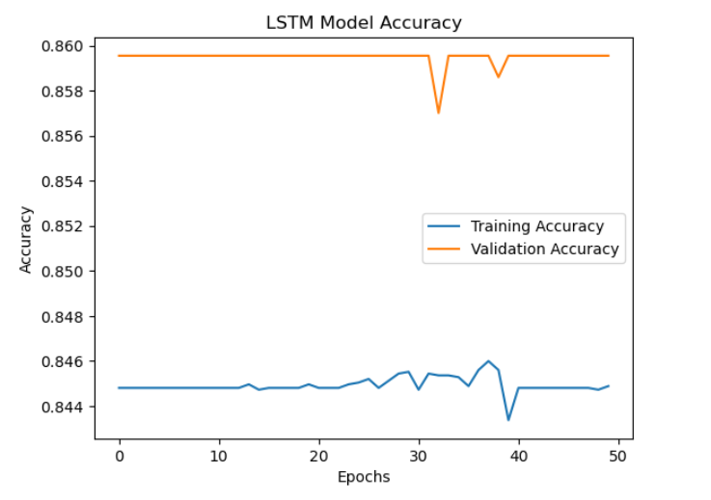

Linear Regression

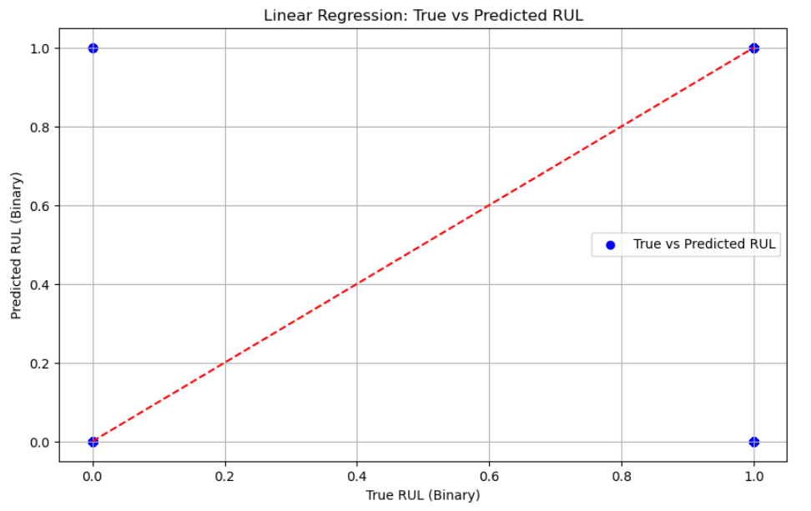

EDA (Exploratory Data Analysis)

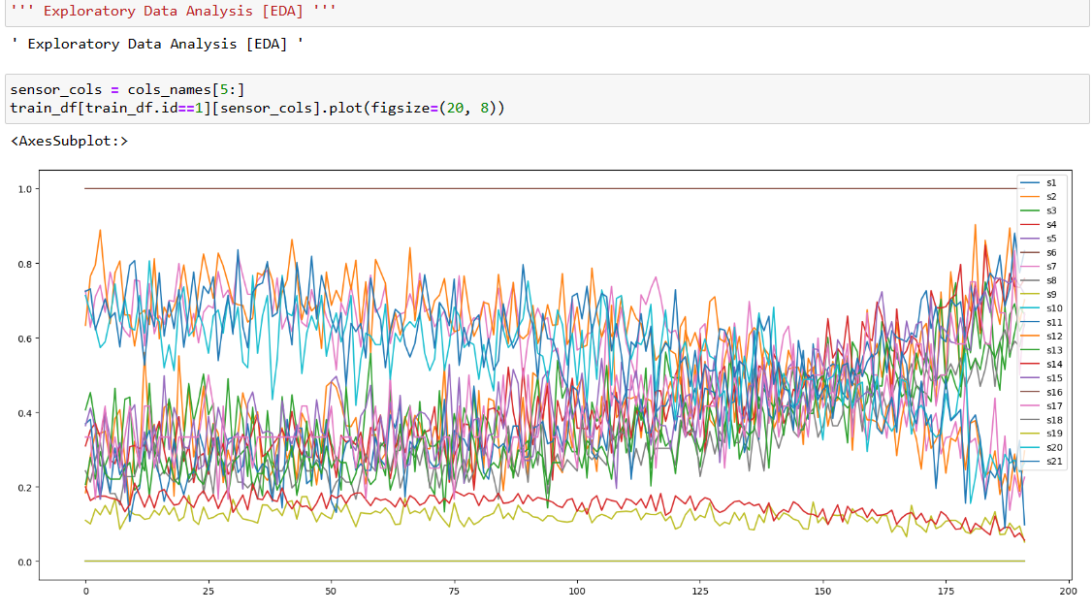

RNN

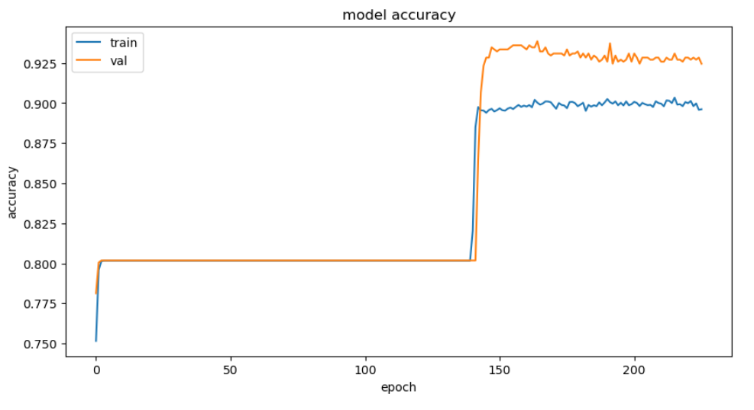

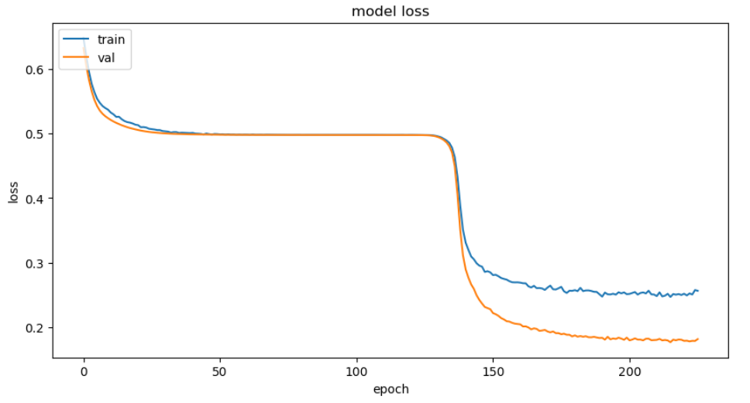
6. Conclusion
6.1. Summary of Findings
In this document, we have outlined the low-level design (LLD) of a predictive maintenance system tailored for aircraft engines. By leveraging various machine learning models including Linear Regression, Long Short-Term Memory (LSTM), Recurrent Neural Networks (RNN), Gradient Boosting (GBU), and Random Forest (RF), our system aims to analyse sensor data, flight patterns, and historical maintenance records to predict the likelihood of engine failure. Throughout the document, we have delved into the architectural design, training processes, evaluation methodologies, and data preprocessing techniques essential for the development and implementation of such a proactive maintenance solution.
During the model implementation and evaluation phase, we provided detailed insights into each model's training process, hyperparameter tuning, and evaluation metrics. By evaluating the performance of these models using metrics such as accuracy, precision, recall, and F1 score, we gained valuable insights into their effectiveness in predicting maintenance needs for aircraft engines.
6.2. Future Work
While the models presented in this document showcase promising results, there is still ample room for improvement and future exploration. Suggestions for future work include:
- Exploring Additional Models: Investigating the potential of additional machine learning models beyond those discussed in this document could provide further insights and potentially enhance predictive capabilities.
- Refining Existing Models: Continuously refining existing models by fine-tuning hyperparameters, optimizing feature engineering techniques, and exploring advanced algorithms can help improve the accuracy and robustness of the predictive maintenance system.
- Integration with Real-Time Data: Integrating real-time data streams into the predictive maintenance system can enhance its responsiveness and adaptability, enabling more timely and accurate predictions of engine failures.
- Enhancing Visualization Techniques: Further enhancing visualization techniques to provide intuitive and comprehensive insights into model performance and data trends can facilitate better decision-making for aviation maintenance experts and stakeholders.

By pursuing these avenues of future work, we aim to continuously advance the predictive maintenance system, ultimately contributing to improved aviation safety, reduced downtime, and enhanced operational efficiency.

